**SIGN IN**

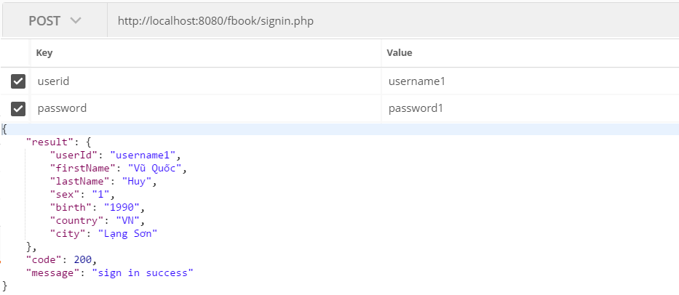

HTTP Res: **POST**

Paramester: **userid:** username to authenticate user account, unique and must be 6 to 24 characters, ascii–latin-general (a-z, A-Z, 0-1) no space char and specify char.

**password:** password to authenticate user account, unique and must be 6 to 24 characters, utf8.

Result Callback:

Login Success Code: Result:

**200** user profile

Login Failed Code: Result:

**999** failed

Error Code: Description:

**101** required parameters is missing.

**102** required parameters is invalid